DigiOz .NET Portal
Chat Room Design Document
The Chat Room user window will look like this:
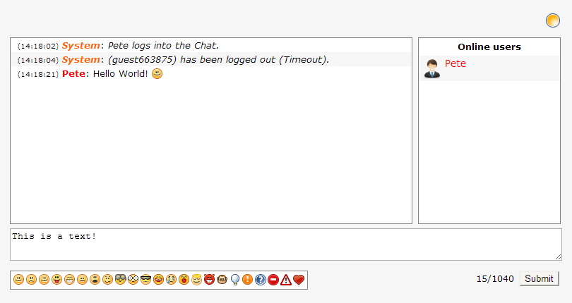
The various regions are broken down as follows:
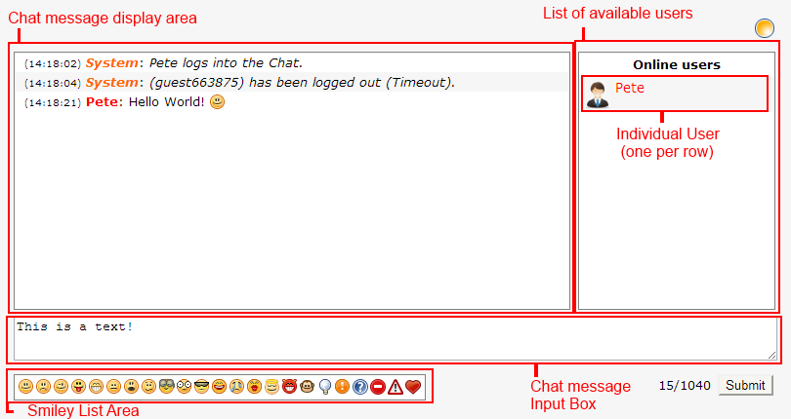
The flow of the chat room is as follows:
- If the user is logged into the portal, their Username is displayed in the “Online Users” section, and their username will be hyperlinked to their Public Profile Page.
- If the user is NOT logged into the portal, we still allow the user to enter the chat, but will set their chat username as “guestXXX”, where “XXX” is the next integer number available.
- When a user types a message in the “Chat Message input Box”, the chat message will appear in the “Chat Message Display Area”, and at the same time will be written to the database.
- All text entered into the “Chat message Input Box” should be checked for special characters and cleaned before showing it in the display area or writing it to the database.
- When a user clicks on the smiley icon, the relevant character (for example “:)” for is appended to the end of the message in the Chat message Input Box.
- Only the last 20 messages should be shown in the chat window at any given time, but the rest of them still remain in the database.
- System events such as users entering or leaving the chat room are shown to be posted by the user “System”.

Admin Area
The Admin Area of the Chat will have the following options shown:
- Index - Will show a list of available options the same way the Dashboard Index currently shows it.
- List – Shows a grid listing of all the messages in the database in DESC order.
- Archive – This feature will display a form with the following fields:
  - Start Date – Options here will be “Beginning” or an actual Date.
  - End Date – Options here will be “End” or an actual Date, whereas the Start Date cannot be more recent then the end date.
When the Admin presses the submit button here, all the messages are exported to plain text and written to a text file, and prompt the Admin for download.
- Block User – This feature should allow the Admin to block a specific username from entering the chat.

